**WEEK 2**

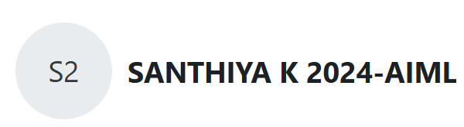

**Question 1:**

**Each Sunday, a newspaper agency sells X copies of a certain newspaper for Rs. A per copy. The cost to the agency of each newspaper is Rs. B . The agency pays a fixed cost for storage, delivery and so on of Rs.100 per Sunday.**[**The newspaper agency**](http://www.rajalakshmicolleges.org/moodle/mod/quiz/view.php?id=54)**wants to calculate the profit obtained on Sundays. Can you please help them out by writing a C program to compute the profit given X, A and B.**

**Program:**

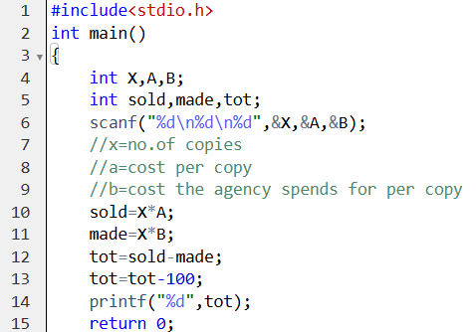

**Output:**

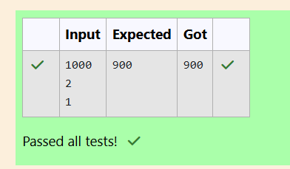

**Question 2:**

**Baba is very kind to beggars and every day Baba donates half of the amount he has when ever a beggar requests him. The money M left in Baba's hand is passed as the input and the number of beggars B who received the alms are passed as the input. The program must print the money Baba had in the beginning of the day.**

**Program :**

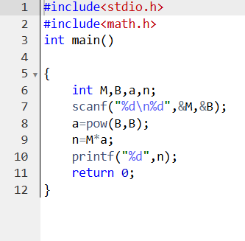

**Output :**

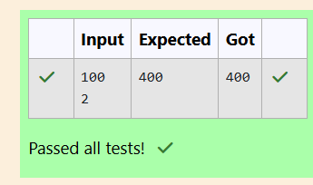

**Question 3:**

**The CEO of company ABC Inc wanted to encourage the employees coming on time to the office. So he announced that for every consecutive day an employee comes on time in a week (starting from Monday to Saturday), he will be awarded Rs.200 more than the previous day as "Punctuality Incentive". The incentive I for the starting day (ie on Monday) is passed as the input to the program. The number of days N an employee came on time consecutively starting from Monday is also passed as the input. The program must calculate and print the "Punctuality Incentive" P of the employee.**

**Program:**

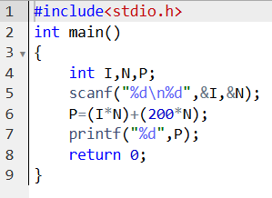

**Output:**

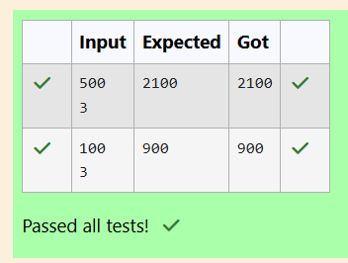

**Question 4:**

**Bajan Lal distributes C chocolates to school N students every Friday. The C chocolates are distributed among N students equally and the remaining chocolates R are given back to Bajan Lal.Help the school to calculate the chocolates to be given back when C and N are passed as input.**

**Program:**

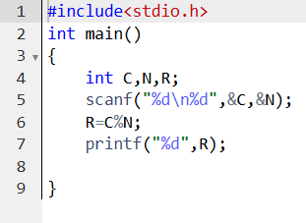

**Output:**

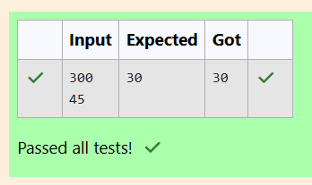

**Question 5:**

**Fill in the missing code in the below program to check whether the given number is divisible by 3 or not.**

**Program:**

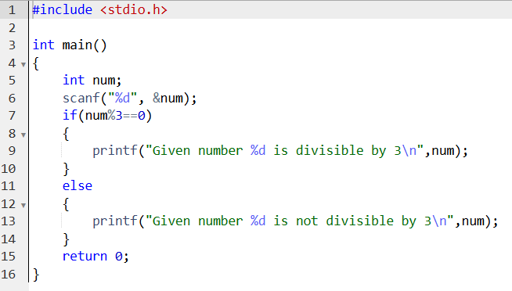

**Output:**

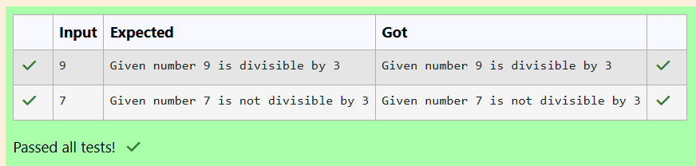

**Question 6:**

**i)Fill in the missing code in the below program to check whether the user secured distinction or not.**

**Program:**

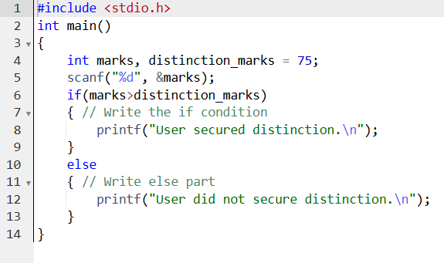

**Output :**

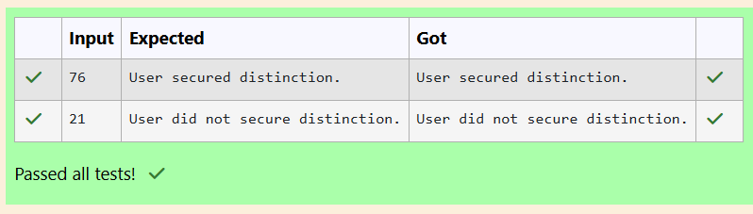

**ii)** **Write code which uses an if-else statement to check whether a given account balance is greater or lesser than the minimum balance.Use the if-else statement and print "Balance is low" if the balance is less than 1000, otherwise print "Sufficient balance".**

**Program :**

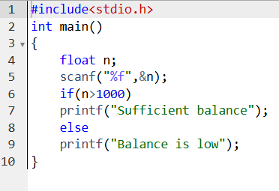

**Output :**

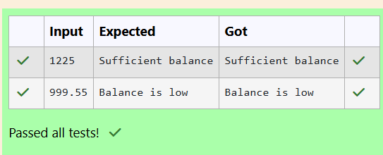

**iii)** **Fill in the missing code in the below program to check whether the student secured first class or not.**

**Program :**

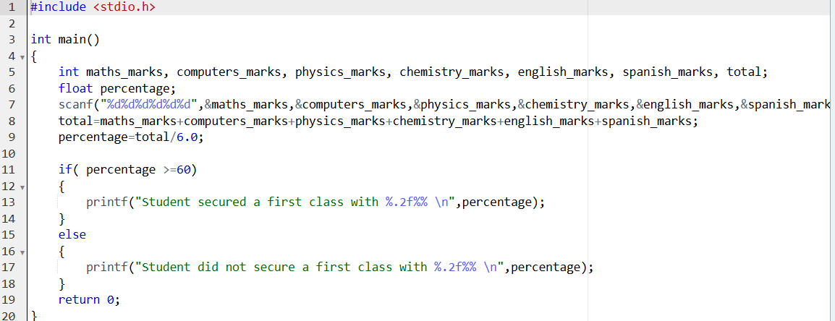

**Output :**

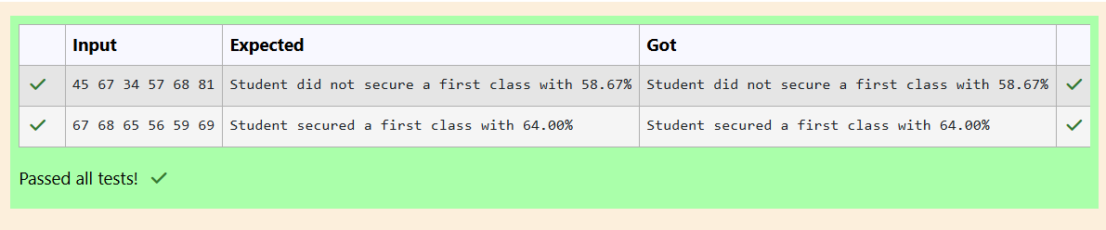

**iv)** **Write a program which uses an if-else statement to verify and print if the given number is an odd or an even.**

**Program :**

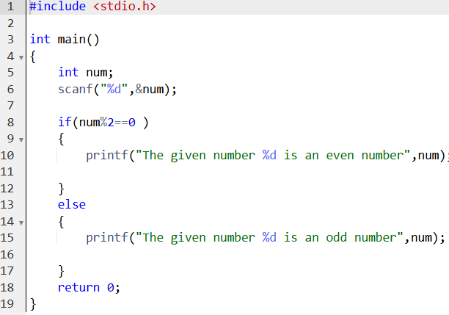

**Output :**

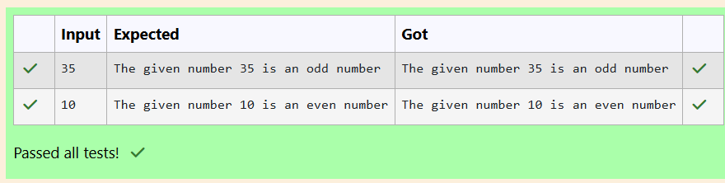

**v)** **Write a program which uses an if-else statement to verify if the given character is an alphabet or not.**

**Program :**

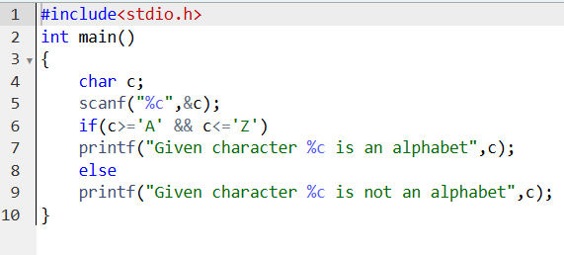

**Output :**

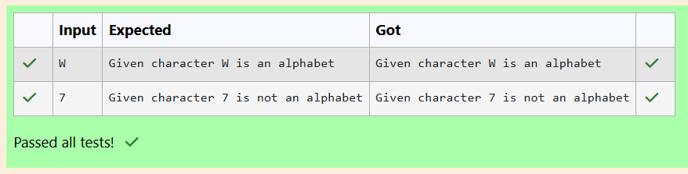

**Question 7:**

**Fill in the missing code in the below program to find the largest of three numbers using nested if-else.**

**Program:**

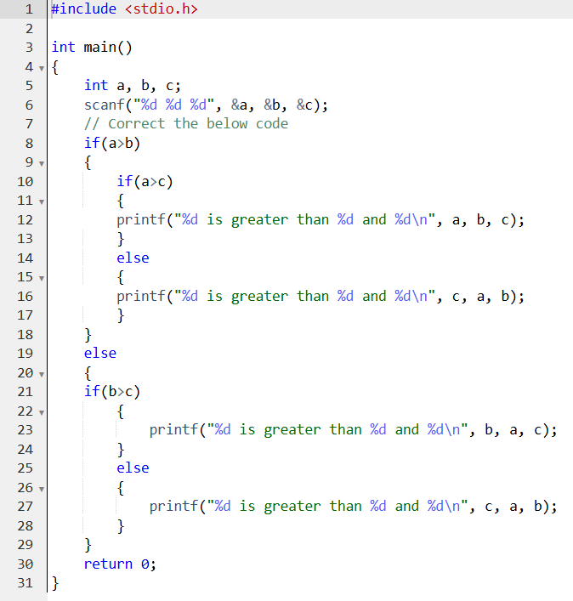

**Output :**

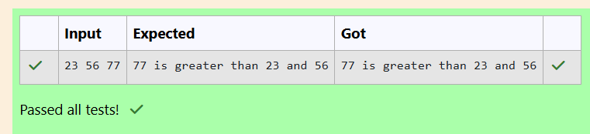

**Question 8:**

**i)The below program reads a character from the console and should print if the given character is an alphabet or a digit. Do not remove the existing code, add the missing lines of code which employs the if-else-if statement to produce appropriate output.**

**Program :**

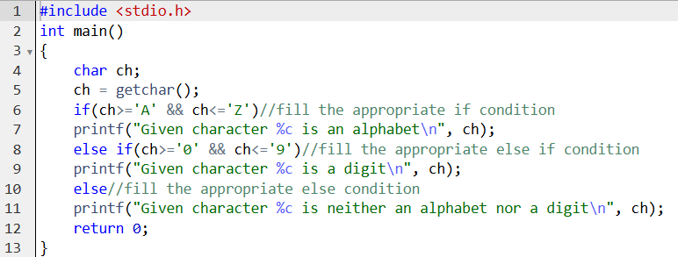

**Output :**

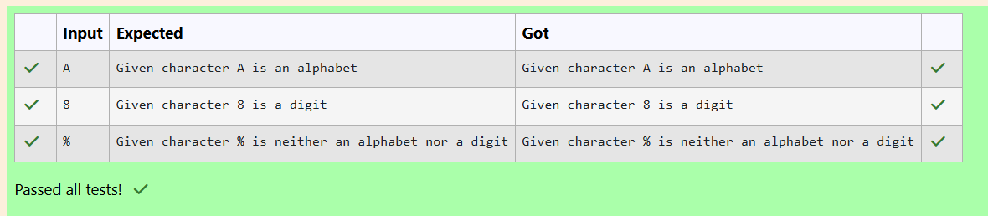

**ii)** **Fill in the missing code in the below program to check whether the given year is a leap year or not.**

**Program :**

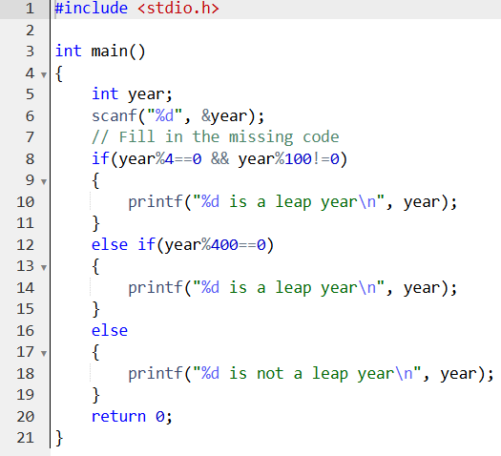

**Output :**

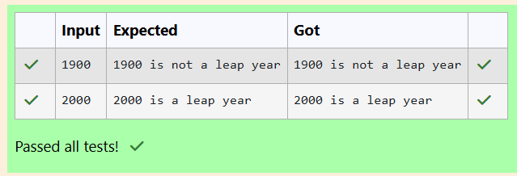

**iii)** **Fill in the missing code in the below program to read an integer value for a variable age and use if-else statement to check the age and print appropriate ticket price.  
If age is less than or equal to infant age (3 years) or greater than or equal to centenarian age (100 years) then print Ticket Price: 0.Otherwise, If age is less than or equal to child age (13 years) or greater than or equal to senior citizen age (60 years) then print Ticket Price: 5. Otherwise, print Ticket Price: 10.**

**Program :**

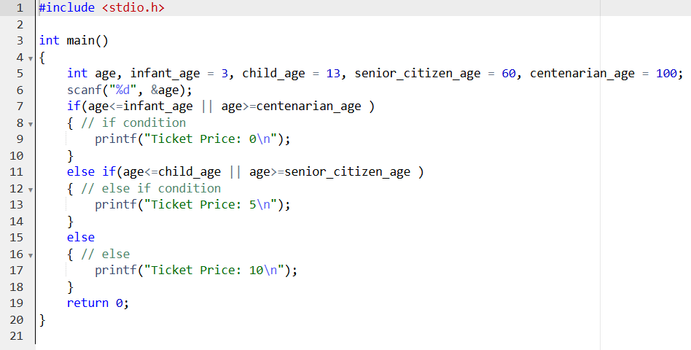

**Output :**

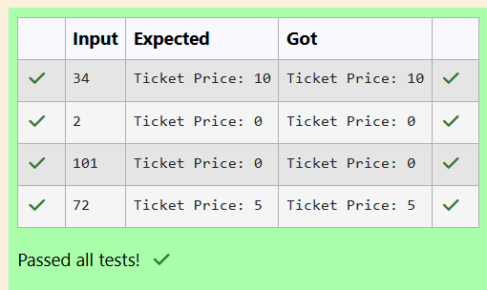

**iv)** **Fill in the if condition to check if the given hour is between 0 and 11 (both inclusive) for AM. Fill in the else if condition to check if the given hour is between 12 and 23 (both inclusive) for PM.**

**Program :**

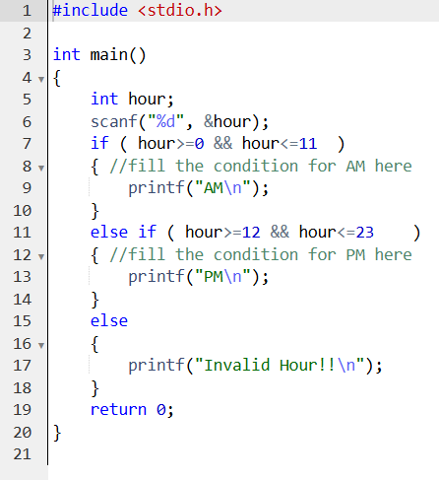

**Output :**

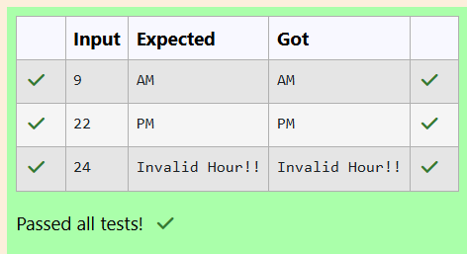

**Question 9:**

**i)See and retype the below code which demonstrates the usage of switch statement to print the English word of the given number between 1 to 9.**

**Program :**

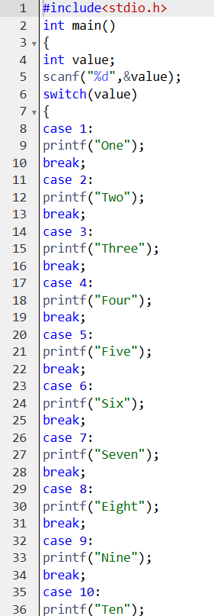

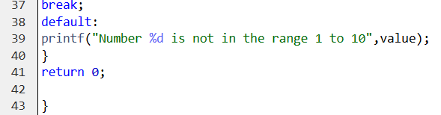

**Output :**

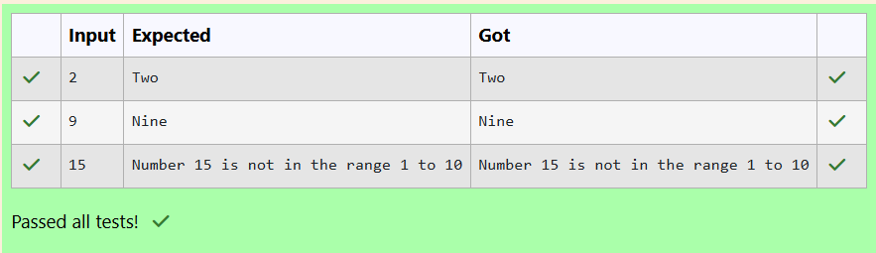

**ii)** **Write a program to read the weekday number from the standard input and print the weekday name using switch-case.**

**Program :**

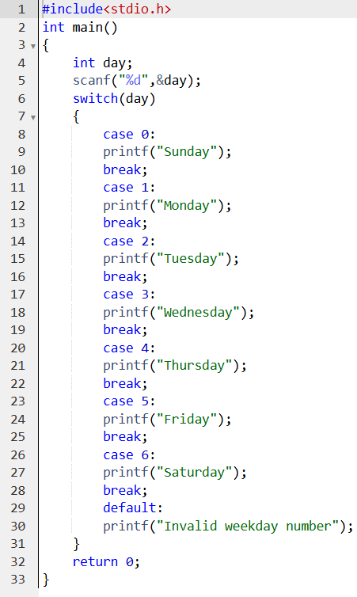

**Output :**

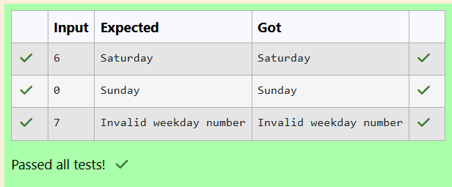

**Question 10:**

1. **See and retype the below code which uses a while-loop to read multiple numbers from standard input and prints their sum when the sum exceeds 100.**

**Program :**

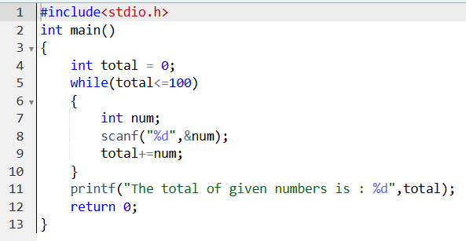

**Output :**

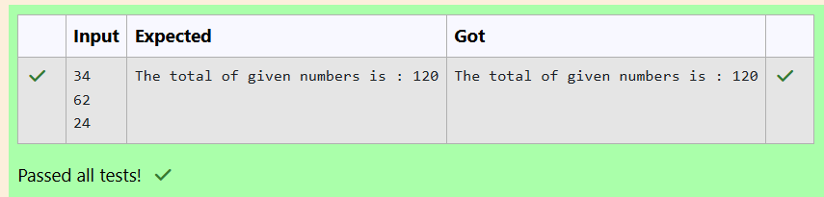

1. **Fill in the missing code so that it produces the desired output.**

**Program :**

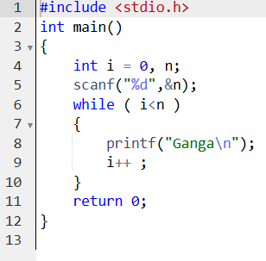

**Output :**

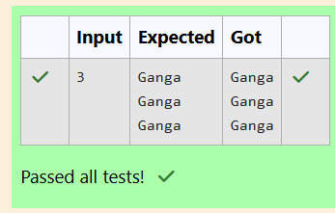

1. **Write a C program to print first n natural numbers.**

**Program :**

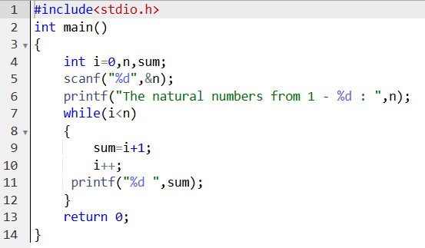

**Output :**

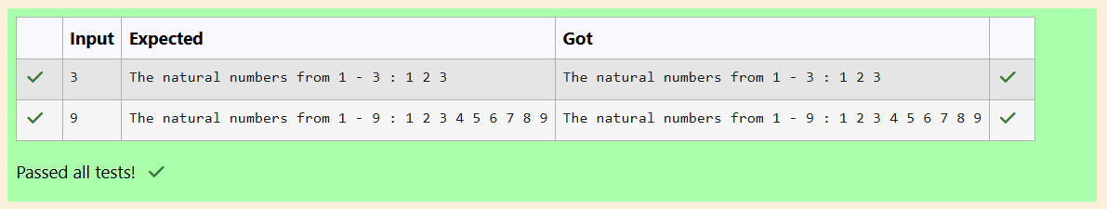

1. **The below sample code should find the sum of even numbers between any two numbers.**

**Program :**

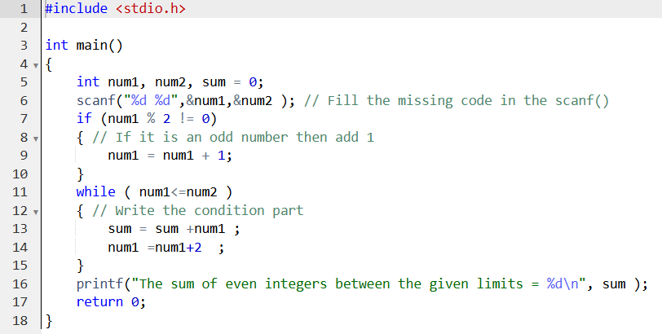

**Output :**

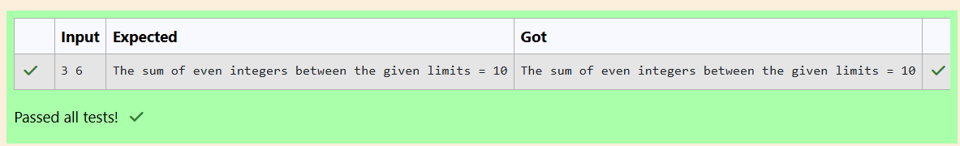

1. **Fill in the missing code in the below program to read an integer number and find the reverse of the given number.**

**Program :**

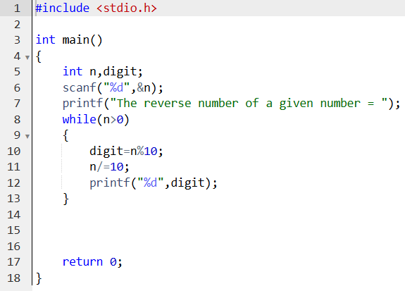

**Output :**

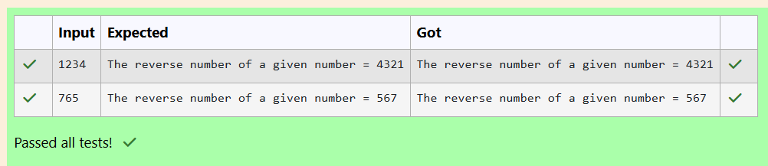

1. **Fill in the missing code in the below sample program which finds the factorial of a given number.**

**Program :**

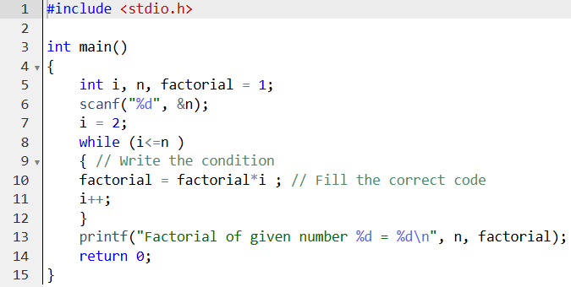

**Output :**

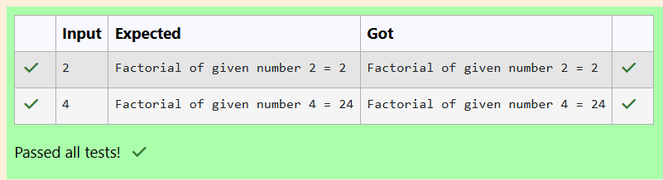

1. **Below partial code is to verify if the given number is a prime number or not.**

**Program :**

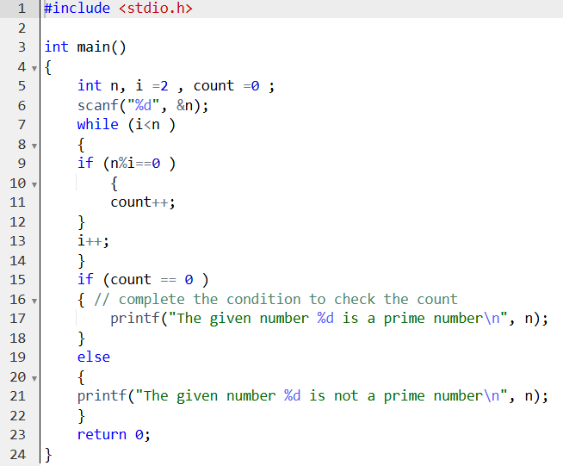

**Output :**

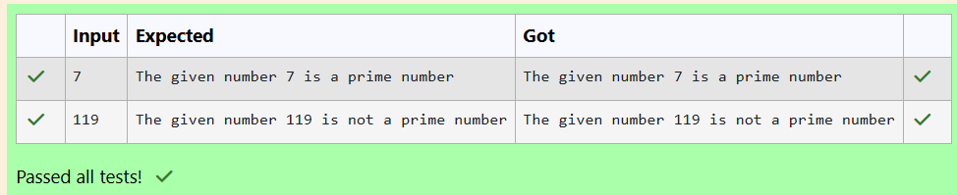

1. **Below partial code is to verify if the given number is an armstrong number or not.**

**Program :**

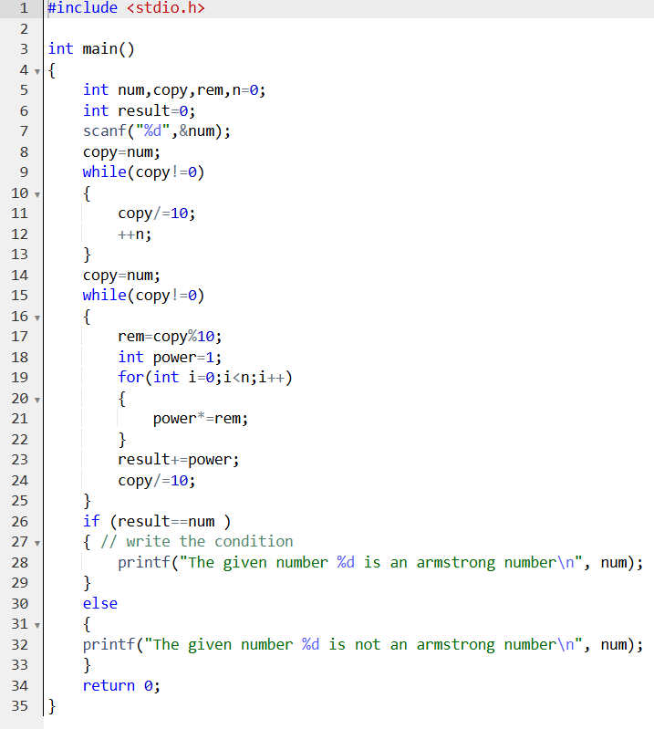

**Output :**

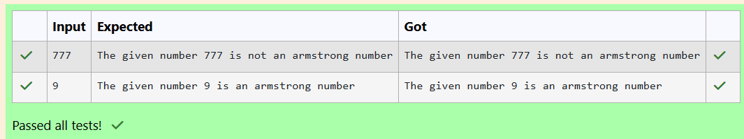

**Question 11:**

1. **Complete the below code to check your understanding of the for-loop syntax.The completed code should print numbers from 10 to 20, one per line.**

**Program :**

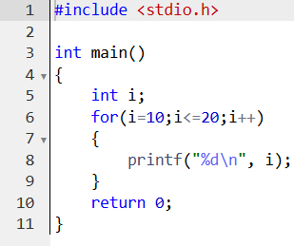

**Output :**

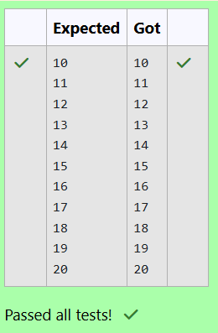

1. **Fill in the missing code in the below program to calculate the value of an, given two positive non-zero integers a and n.**

**Program :**

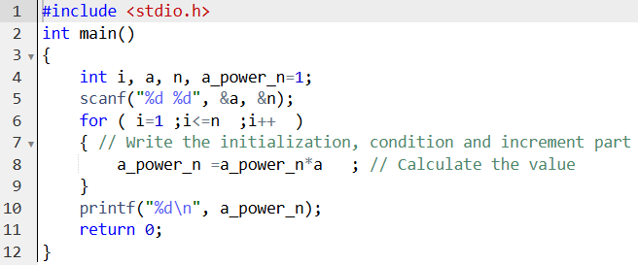

**Output :**

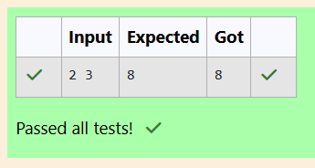

1. **Write a program to find sum and mean of n numbers.**

**Program :**

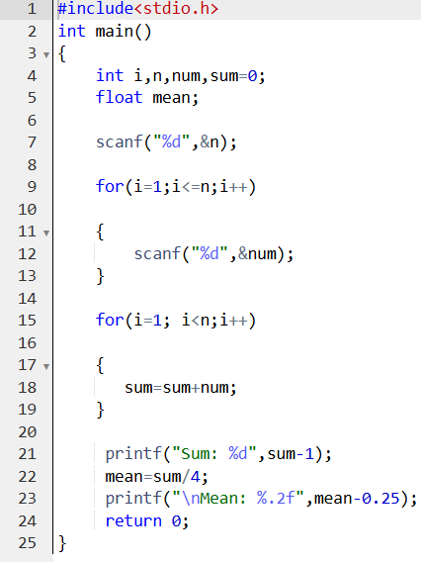

**Output :**

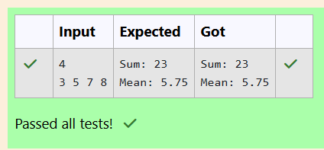

1. **Fill in the missing code in the below program to print the Fibonacci series i.e., 0 1 1 2 3 5 8 13 21....., up to the limit.**

**Program :**

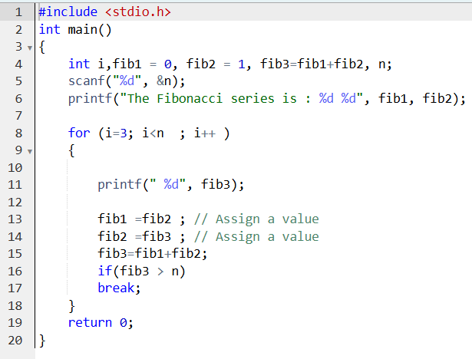

**Output :**

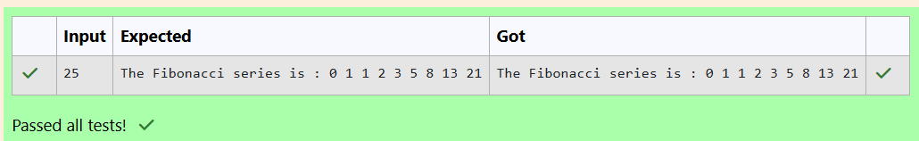

1. **Write a program that will print all the English alphabets from A to Z, each in a new line.**

**Program :**

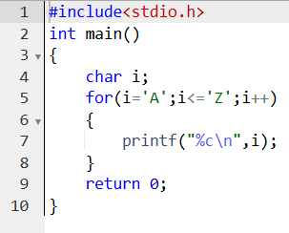

**Output :**

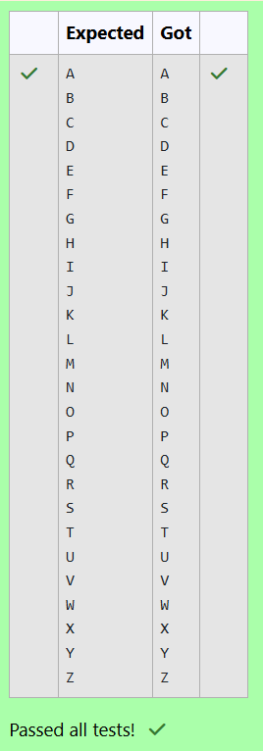

1. **Write a program to read n numbers from the user and then count number of "Odd" and "Even" numbers.**

**Program :**

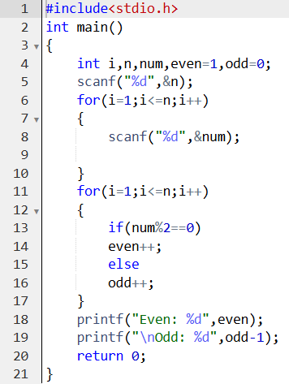

**Output :**

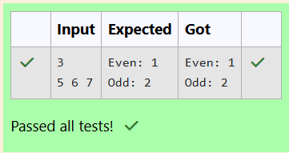

1. **Fill in the missing code in the below program to verify whether the given number is perfect, abundant or deficient.**

**Program :**

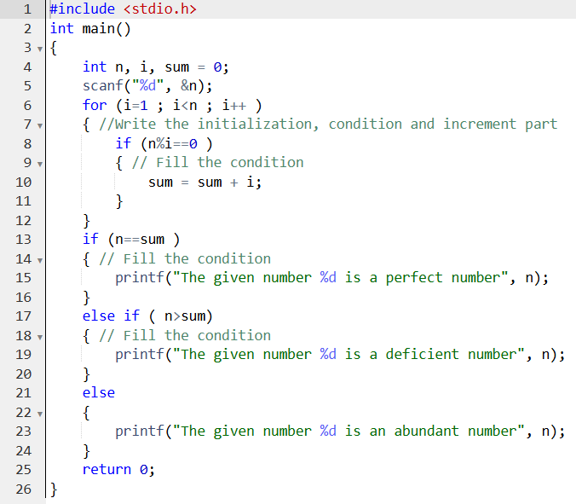

**Output :**

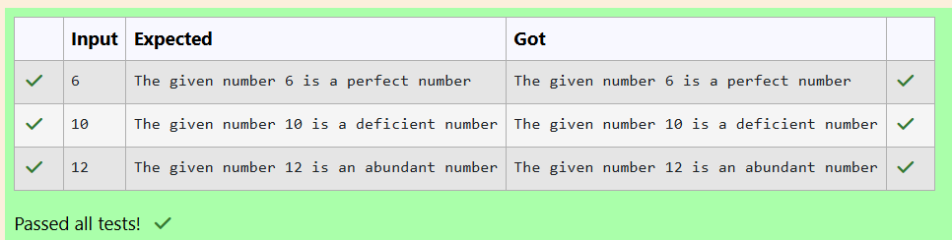

1. **Fill in the missing code in the below program to check whether the given number is a strong number or not.**

**Program :**

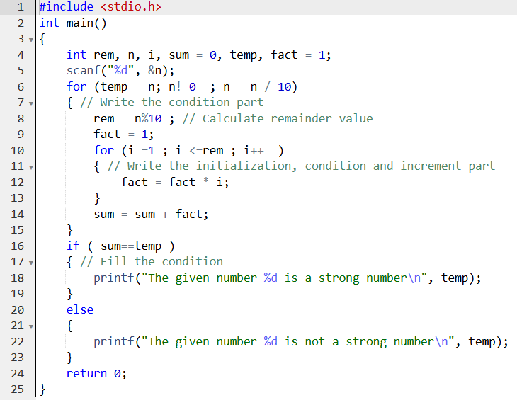

**Output :**

